**Eva Harston**

**Brother Ralph Borcherds**

**WDD 130-B6**

**04 November 2023**

**Tiny Trails Content**

**Home**

**Hero Image:**



**Hero Message:**

“We must teach our children to smell the earth, to taste the rain, to touch the wind, to see things grow, to hear the sun rise and night fall – to care.” John Cleal

**Main**

Buttons for hikes by age

* 0-18 Months, 18 Months – 2yrs old, 2yrs old-3yrs old, 3yrs old-4yrs old, 4yrs old-5yrs old

Benefits of Outdoor Free Play

https://timbernook.com/our-approach-outdoor-experiential-learning-play/therapeutic-benefits/

* Increased Creativity/ Problem solving skills
  + 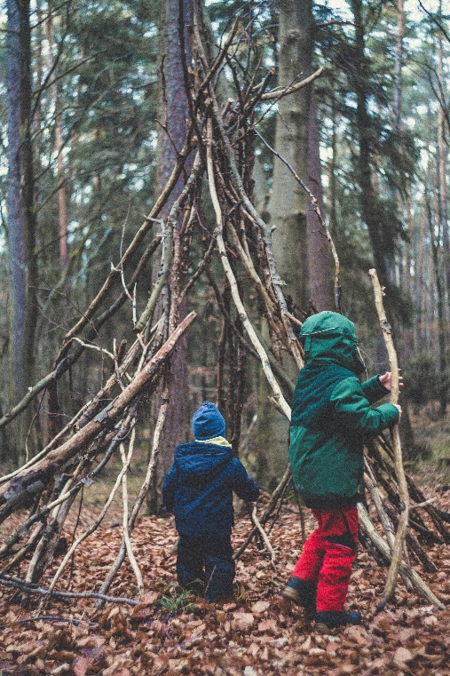
* Increased Gross & Fine Motor skills
  + 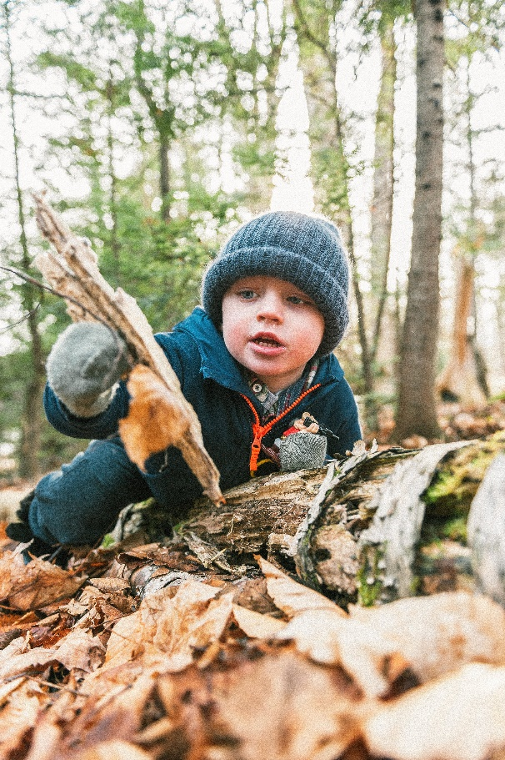
* Increased Mental Health
  + 
* Improved Vestibular System
  + 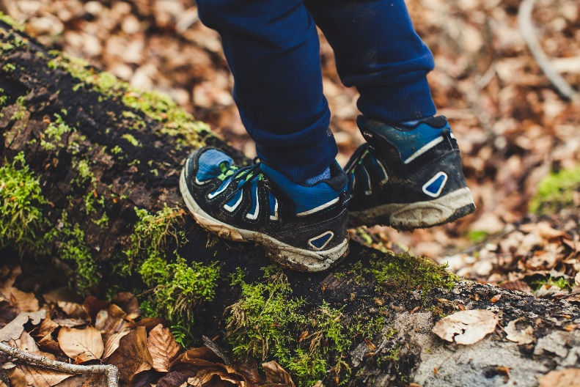
* Improved Attention
  + 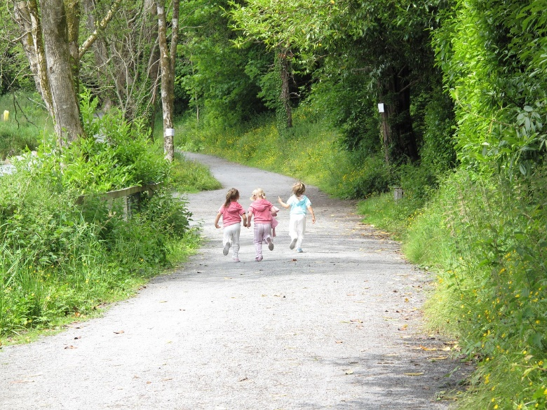

**Suggested mileage for age**

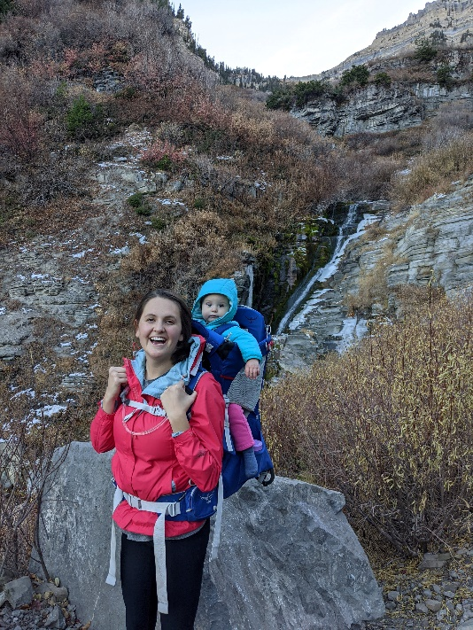 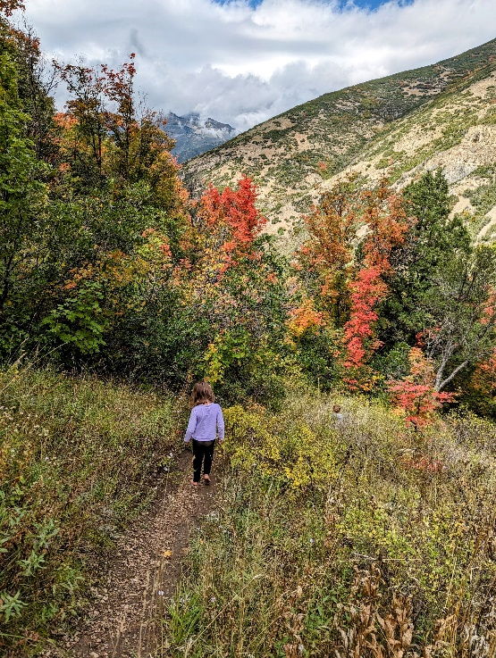 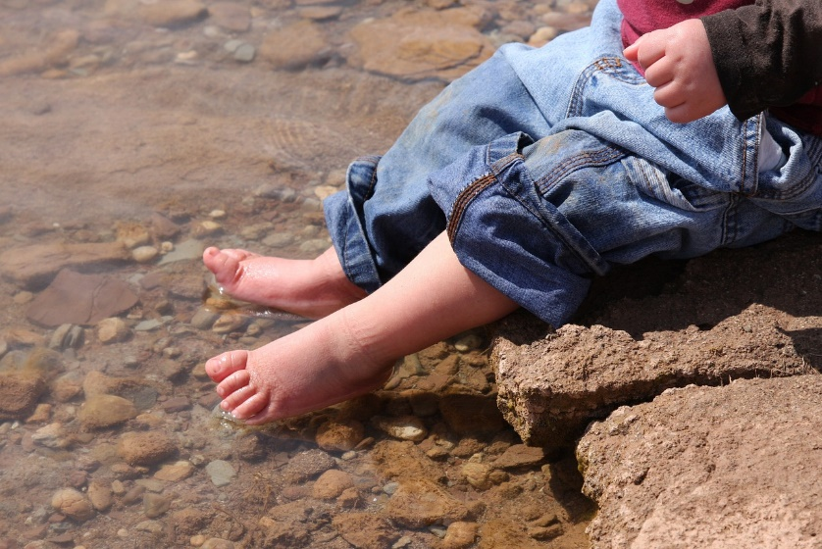

**0-18 months – Using a baby carrier, taking a stroller hike, or simply going to a play area are best at this age. Don’t forget to let your infant have time out of the baby carrier or stroller by carrying them in your arms for a time or letting them play on the ground. This will give them an opportunity to use muscles that would otherwise be dormant in a carrier and to explore the world around them.**

**18months – 2year old – play areas and one-mile hikes are the best at this age. Plan for lots of stops to look at rocks, pick up sticks, and look at bugs. Because of exploration plan several hours even though you are not covering much distance**

**2yr-3yr – play areas and 0-2 mile hikes are best. They still will be curious as ever and want to stop to explore often. If you are planning a hike above 1.5 miles it may be a good idea to bring a hiking carrier just in case.**

**3yr-4yr – play areas and 0-3 mile hikes are best. Still count on many unplanned breaks.**

**4yr-5yr – play areas and 0-4 mile hikes. Depending on your child’s previous experience hiking they will be able to start doing longer 4 mile hikes. If you are just getting into hiking it may be good to start with 2 mile hikes, even at this age, to build up children’s experience and stamina.**

**Find A Hike**

1. **Play Areas**
   1. **Big Springs Hollow** 
      1. **https://maps.app.goo.gl/RR7zJ4hpqJmj1aGq8**
   2. **Hobble Creek Canyon/Jolley’s Ranch**
      1. **https://maps.app.goo.gl/vyL6tmiwRjLx87mX6**
   3. **South Fork Park**
      1. **https://maps.app.goo.gl/QFGkB4UVj52hteDg8**
   4. **Wayne Bartholomew Family Park 1**
      1. **https://maps.app.goo.gl/TPnWEDJGGaGwTMh46**

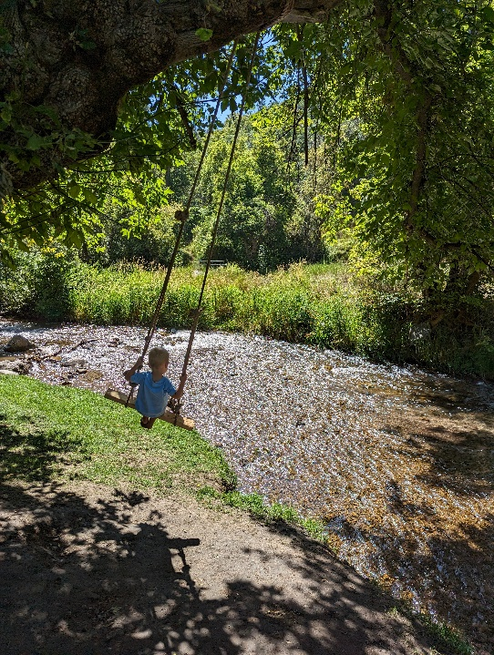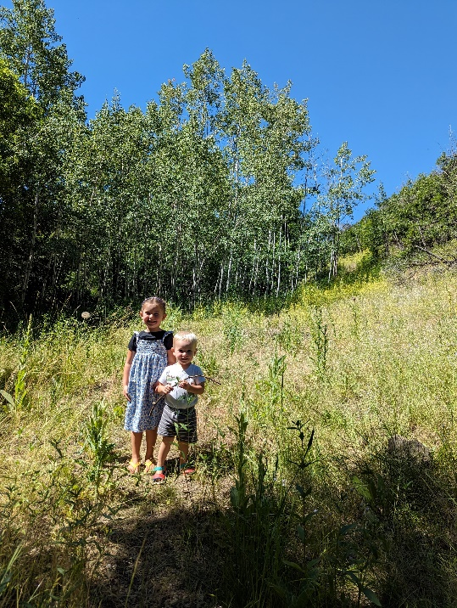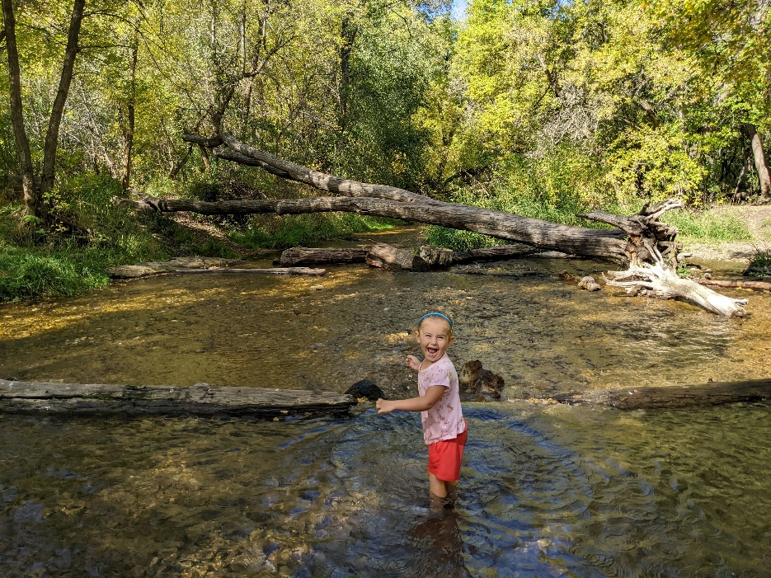

1. **Stroller hikes**
   1. **Big East Lake – 1 mile**
      1. [**https://maps.app.goo.gl/jBRsdSSr9re1tr84A**](https://maps.app.goo.gl/jBRsdSSr9re1tr84A)
   2. **Bridal Veil Falls – 2 miles**
      1. **https://maps.app.goo.gl/arbBg82djNnM51Tn8**
   3. **Dripping Rock Falls – 0.7 miles**
      1. **https://maps.app.goo.gl/e77UcfKeaiHLQQbZA**
   4. **Provo River Trail**
      1. **https://maps.app.goo.gl/uQNFSGo4st5ypdfp7**
   5. 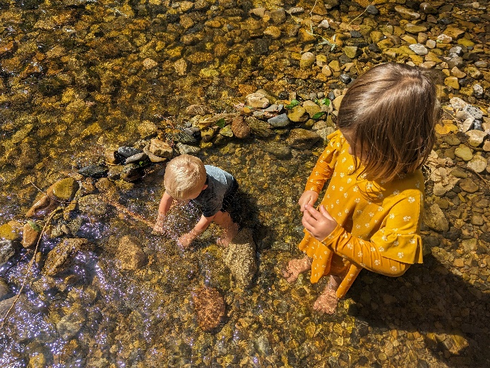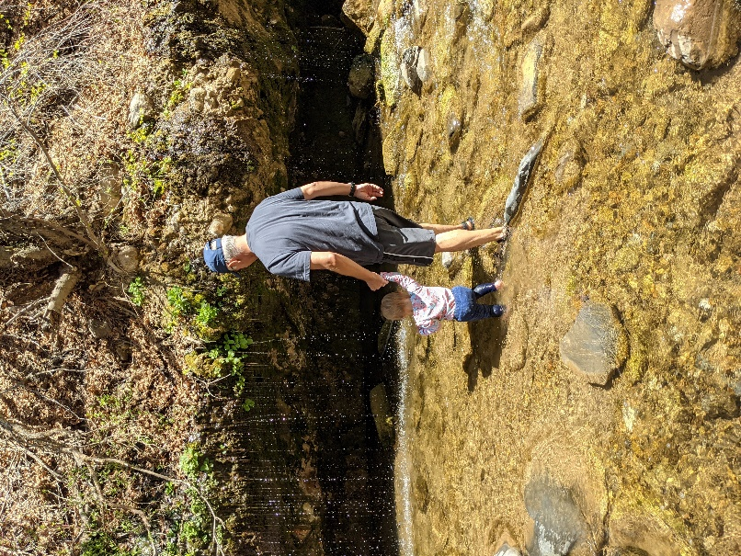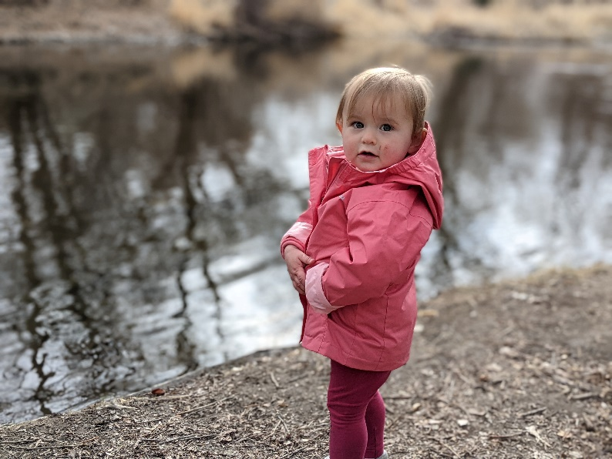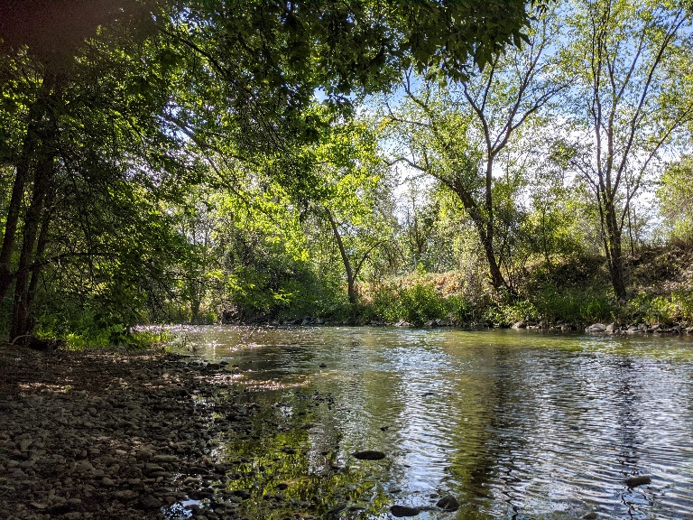
2. **0-1 mile**
   1. **Bonneville Shoreline**
      1. **https://maps.app.goo.gl/6idUXHFmKpVhoHQC8**
   2. **Buffalo Peak Trail – 0.9 miles**
      1. **https://maps.app.goo.gl/Xa7SeSbpyNFF7sNi6**
   3. **Canyon Nature Trail – 0.6 miles**
      1. **https://maps.app.goo.gl/ahSaXJZMC9FqAvxV9**
   4. **Grotto Falls – 0.6 miles**
      1. **https://maps.app.goo.gl/jgQr2pDx7RE9VzY49**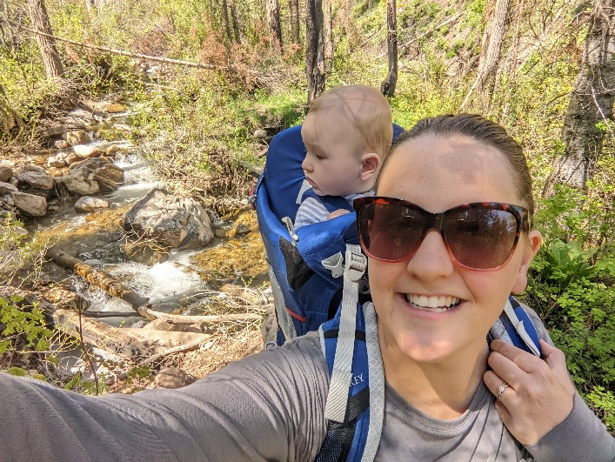 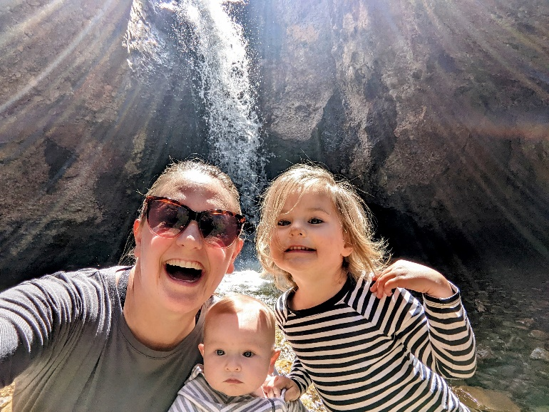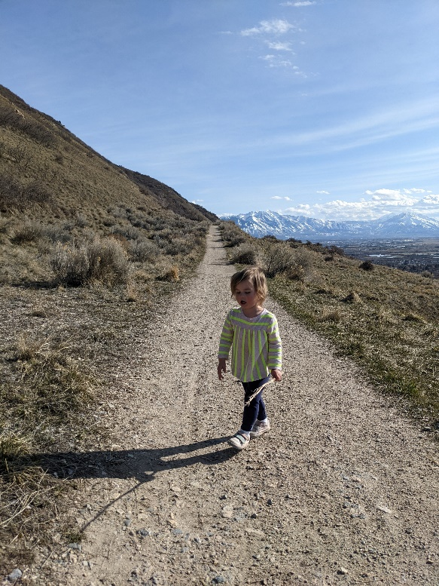
3. **1-2 miles**
   1. **Canyon View Park Provo River Loop – 1.4 miles**
      1. [**https://www.alltrails.com/trail/us/utah/canyon-view-park-provo-river-loop**](https://www.alltrails.com/trail/us/utah/canyon-view-park-provo-river-loop)
   2. **Dominguez Hill 1.7 miles**
      1. [**https://maps.app.goo.gl/6CMaYw9zRH5jxN2o8**](https://maps.app.goo.gl/6CMaYw9zRH5jxN2o8)
   3. **Upper Quito Trail – 2.0 miles**
      1. **https://maps.app.goo.gl/53w3vm98wbbVY42z9**
   4. 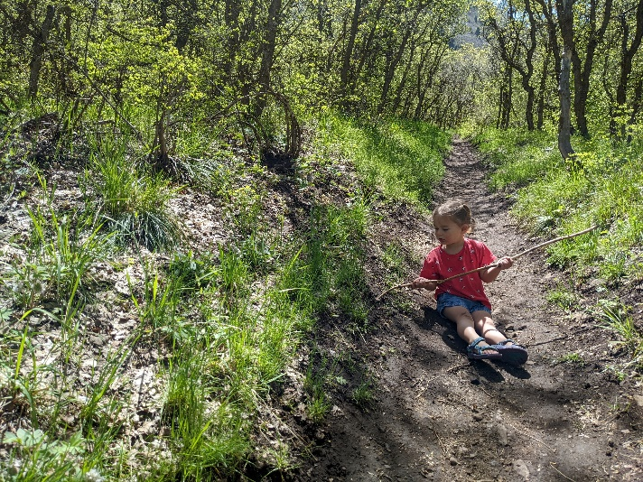
4. **2-3 miles**
   1. **Lost Creek Falls Trail – 2.4 miles**
      1. **https://www.alltrails.com/trail/us/utah/lost-creek-falls-trail**
   2. **Maple Canyon to Whiting Campground – 2.4 miles**
      1. **https://www.alltrails.com/trail/us/utah/maple-canyon-to-whiting-campground**
   3. **Timpanogos Lower Falls 2.4 miles**
      1. **https://www.alltrails.com/trail/us/utah/timpanogos-lower-falls**
   4. 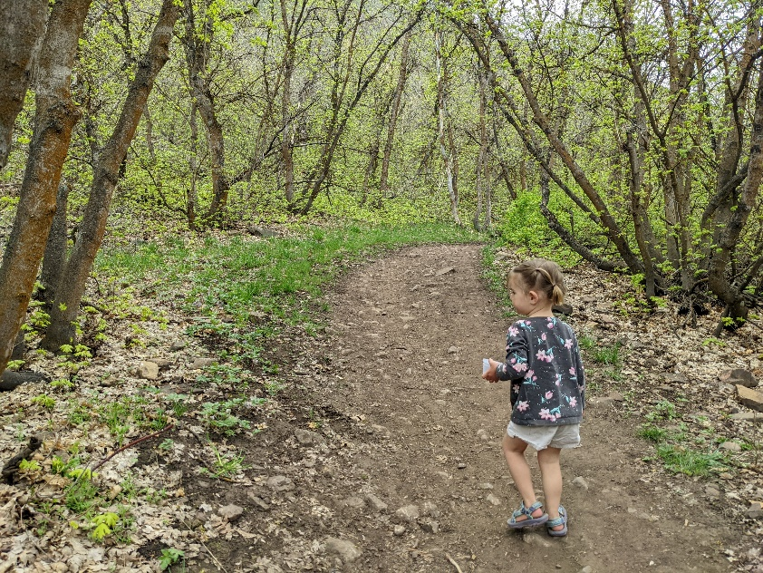
5. **3-4 miles**
   1. **Big Springs hollow Loop 3.9 miles**
      1. **https://www.alltrails.com/trail/us/utah/big-springs-hollow-loop**
   2. **Primrose Overlook via Horse Flat Trail 3.1 miles**
      1. **https://www.alltrails.com/trail/us/utah/primrose-overlook-via-horse-flat-trail**
   3. **Snow Gauging Trail 3.2 miles**
      1. **https://www.alltrails.com/trail/us/utah/snow-gauging-trail**
   4. **Stewart Falls 3.5 miles**
      1. **https://www.alltrails.com/explore/trail/us/utah/stewart-falls-trails**

